**IMPLEMENTATION PLAN WEB PV INVERTER SYSTEM MANAGEMENT**

1. **Technology Requirements**

The required interface display the following parameters:

* **Input:**
* PV: Ipv1, Ipv2, Vpv1, Vpv2, Ppv1, Ppv2.
* Bat: Ibat, Vbat, Pbat. Hiển thị tất cả realtime
* Grid: Vgrid, Freq.
* DC: Udc, Pdc.
* **Output**:
* Power: P
* Energy total of day: Wday.
* Energy total accumulated: Wtotal.
* Freq: f.
* Voltage load: Vload.
* Current load: Iload.
* Voltage grid: Vgrid.
* Current grid: Igrid.
* Direct Voltage: Vdc.

Them nhiet do, do am

Overview chi hien thi dai dien 1 vai dai luong.

Tao them 1 page de hien thi tat ca cac gia tri realtime.

Bỏ bảng data table

1. **Login to system**

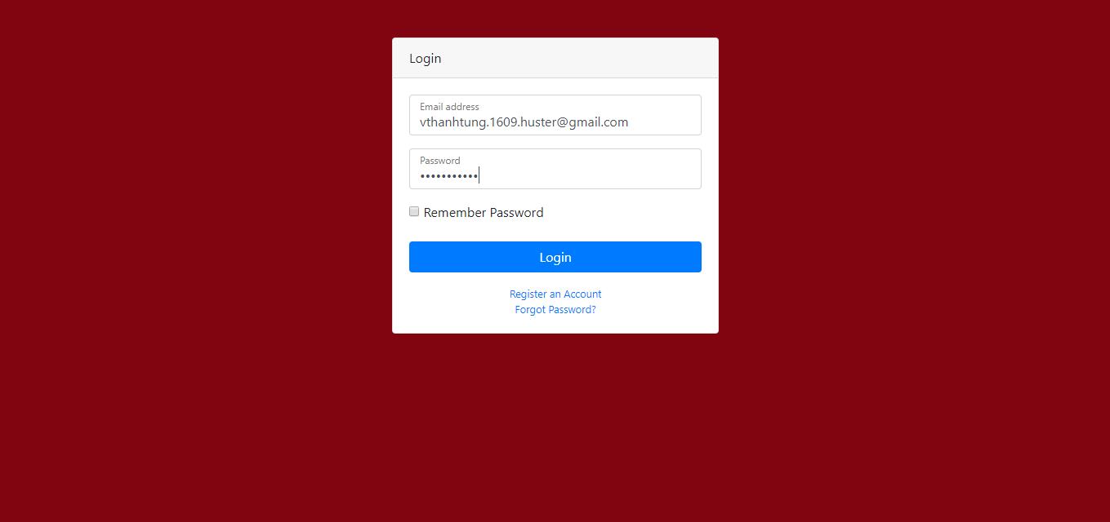

Figure 1: Hình ảnh đăng nhập hệ thống

The purpose of login to system is to help the manager to control who has access to the system.

It will have items such as account registration, password forgotten. The managers can grant access to eligible subscribers.

1. **Dashboard**

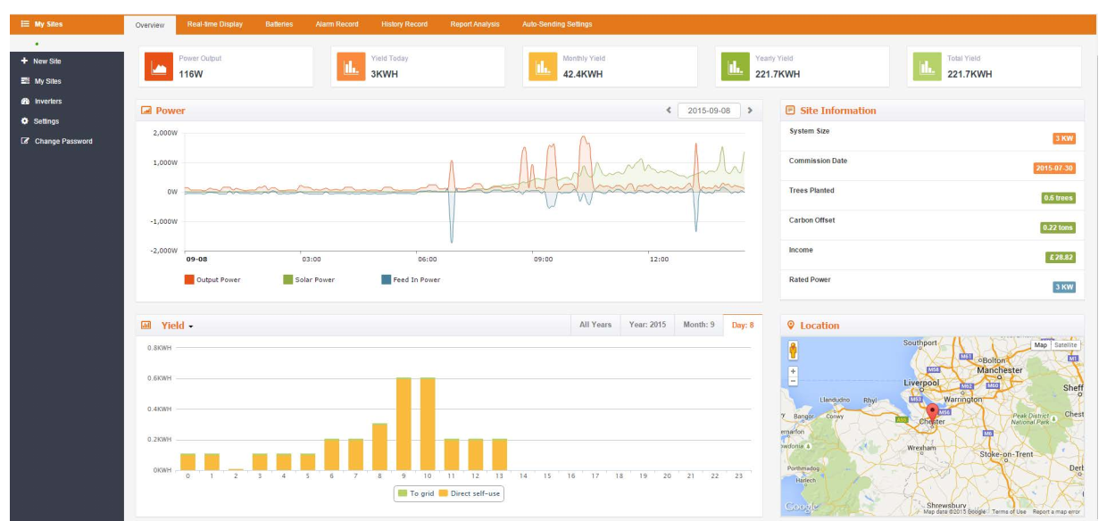

Figure 2: Overview

About the idea I will make as figure 2. This is Dashboard/Overview you will see when you first log into our system assuming you are already created an account and been through setup by admin. It have items such as: the parameters of input/output. You can see the Figure 3.

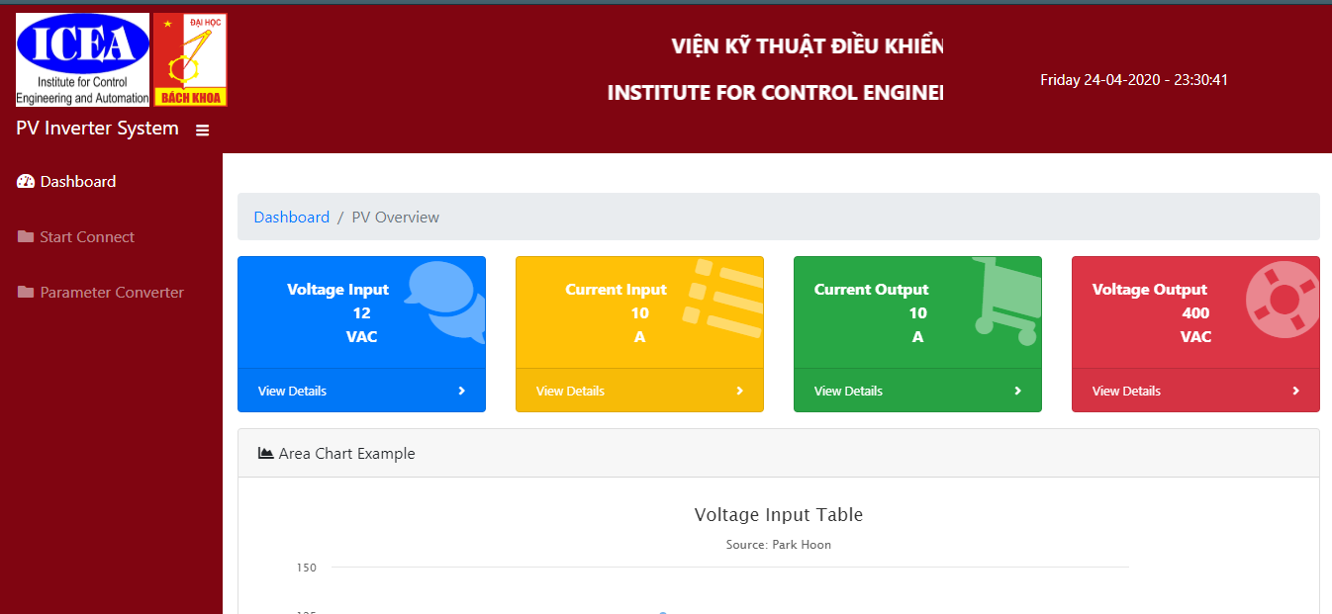

Figure : Dashboard

Gia tri realtime de kiem tra he thong dang hoat dong ntn.

1. **Graph**

You can see Figure 4 (form from solax) there are 2 graph on this screen, one is power and one is yield. Power is a type of graph uses the line chart. Yield is a type of graph uses bar chart.

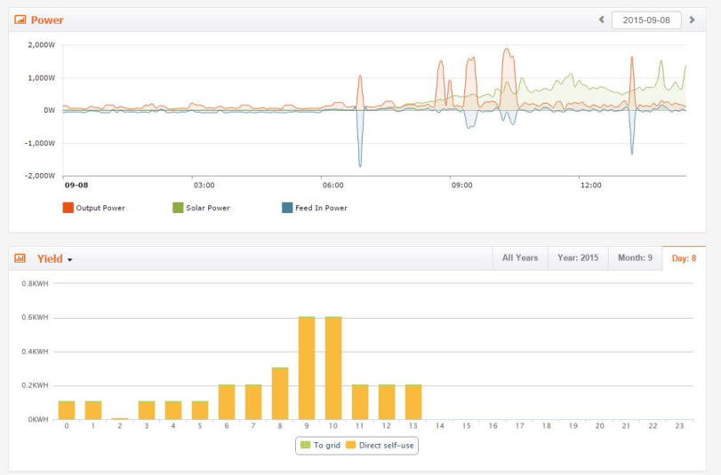

Figure : Graph

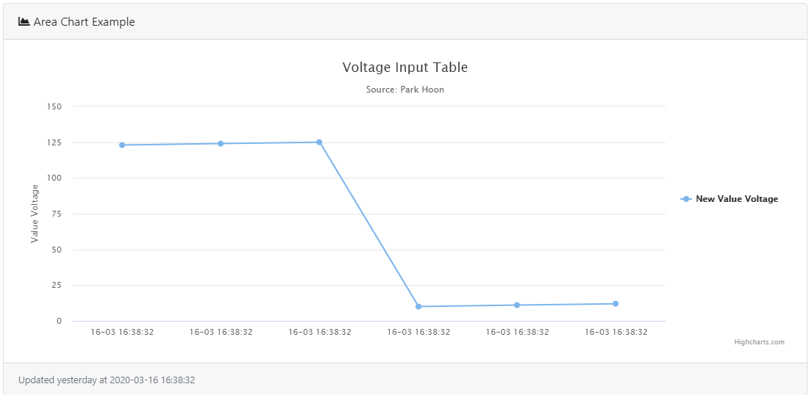

Figure : Graph of PV

Figure 5 is designed by me. It is demo of voltage and current. My purpose is to design each graph for each required value such as: voltage input/output, current input/output,…

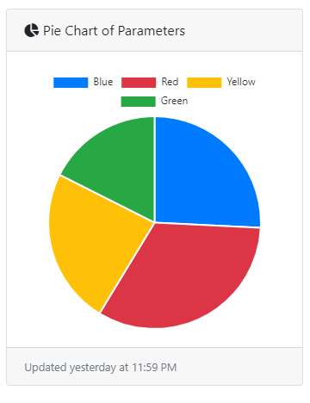

Figure : Pie chart

Figure 6, my idea is to use it for parameter power of day. Bỏ pie chart

1. **Tables**

Where is displays the parameters value received from PV system. You can see figure 6.

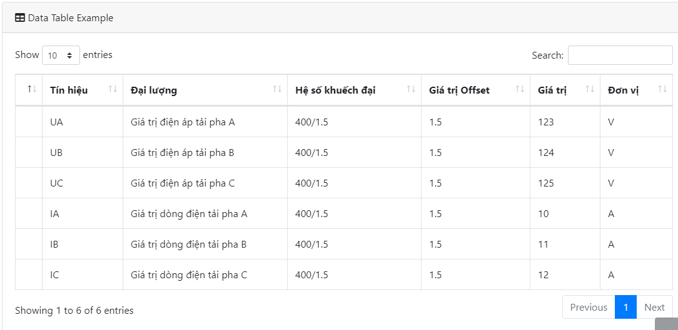

Figure : Tables